University Model

AED ASSIGNMENT 3

* Nirmayee Dighe – 002984202
* Vaishanavi Khismatroa – 001523415
* Sanika Patne - 001099125

**Problem Statement**

To build a university performance model which will help them keep a track of their graduate students and their employment status over a period of 5 years. Also, it will maintain a record of the jobs and promotions, graduates get over time as well as allot rankings accordingly. Compare connections of graduate student courses and relevant growth. Define a ranking system for students to decide where they want to go for their studies.

**Proposed Solution**

In order to create a performance management solution that would analyze the dependency of faculty and courses and how it contributes to the professional growth of graduates, it is essential to keep a record of all courses that the students have taken and how these courses proved to be relevant for their future career. We have also taken surveys from employers which would help us know the current trends in the market. These surveys will help keep departments up to date with the recent technologies and change their curriculum accordingly. Departments would need to store these feedbacks, surveys and should keep getting employment updates from their alumni and employers.

Listed below are the main points that we have captured:

1.    Students should be asked for feedback from students about what courses have proved to be useful during their internships/coop.

2.    Feedback should be taken from students after each semester to understand how well have they understood the course and how has it helped them develop their skill sets.

3.    Surveys should be conducted so that the employers give information on recent industry trends and what skillsets they are looking for in their candidates.

4.    Employer and student interaction should be encouraged so that everyone is in sync with the latest technologies used in the market and other areas of research.

5.    All the certifications, online courses and training received by the student should be stored and analysed.

6.    Departments should analyse the survey data received from the companies and revise the coursework every two to three years.

7.    During their co-op/internships, students should be asked for feedback forms after completing every sprint, this feedback will include data about courses which have helped them.

8.    Higher weightage should be given to the feedback of students who have performed well in their coop and they should be asked for suggestions to help the university in refining its current performance management model.

With the help of the above data, we can compare the relationship between the students’ academics and their industrial performance. Based on the data generated, we can conclude that most of the students with good academics perform well in an industry. However, it is worth noting that there are cases where the students with low academic scores have had more successful careers than others.

**Dashboards:**

* Main Application Dashboard

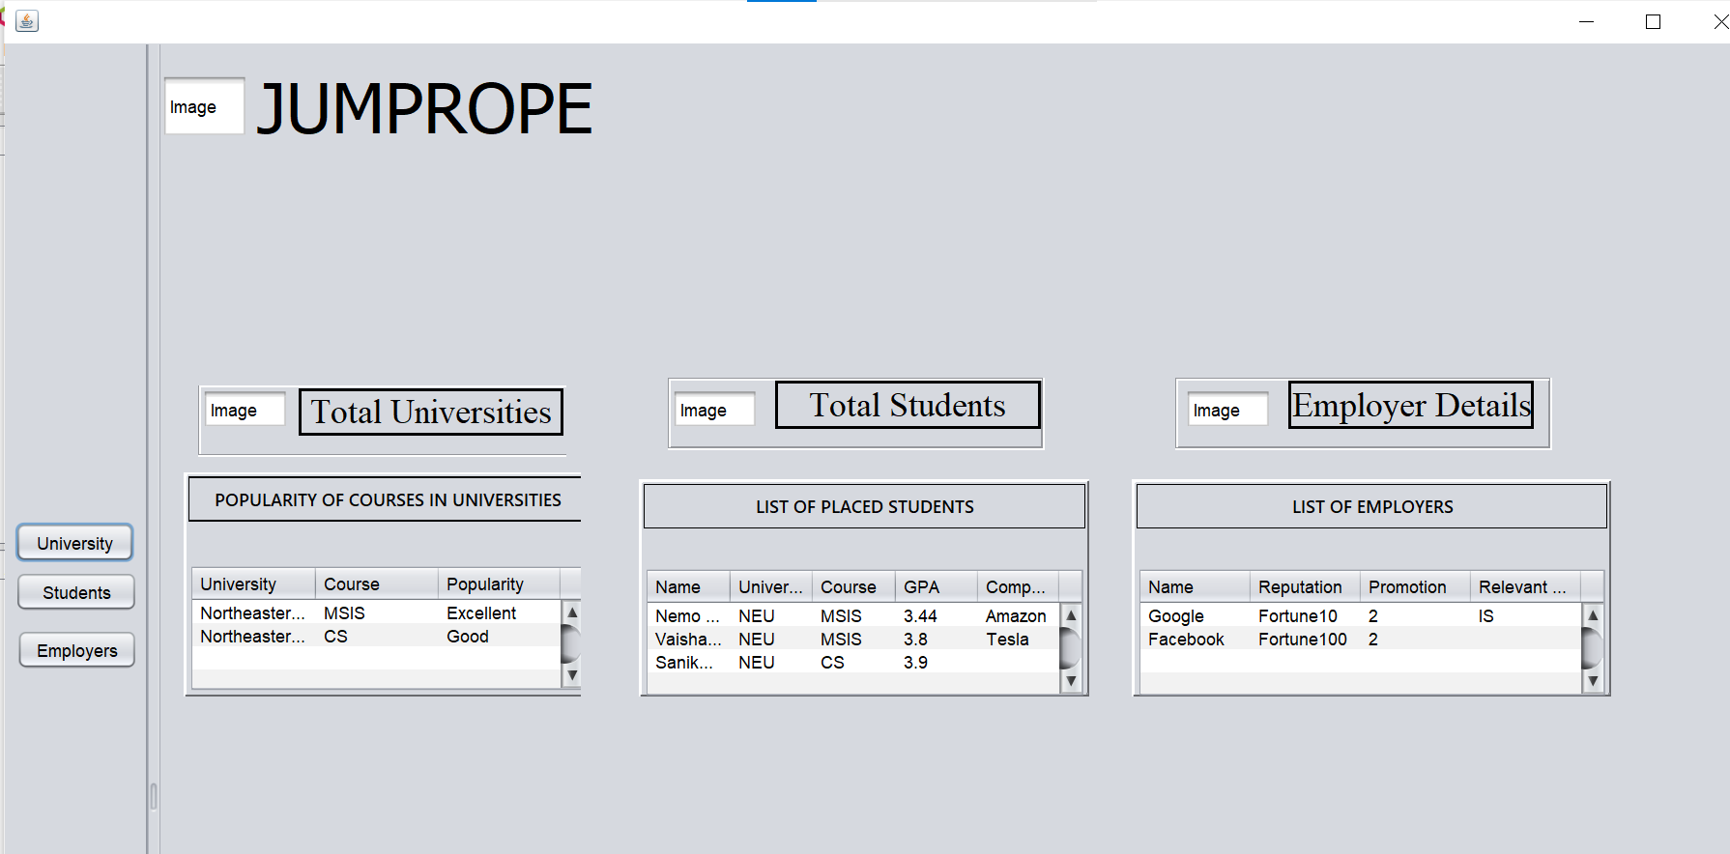

* University View Dashboards

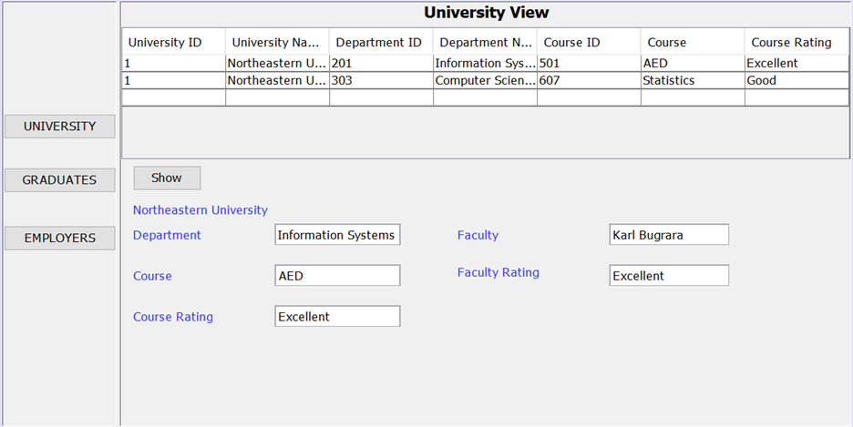

* Student View Dashboard

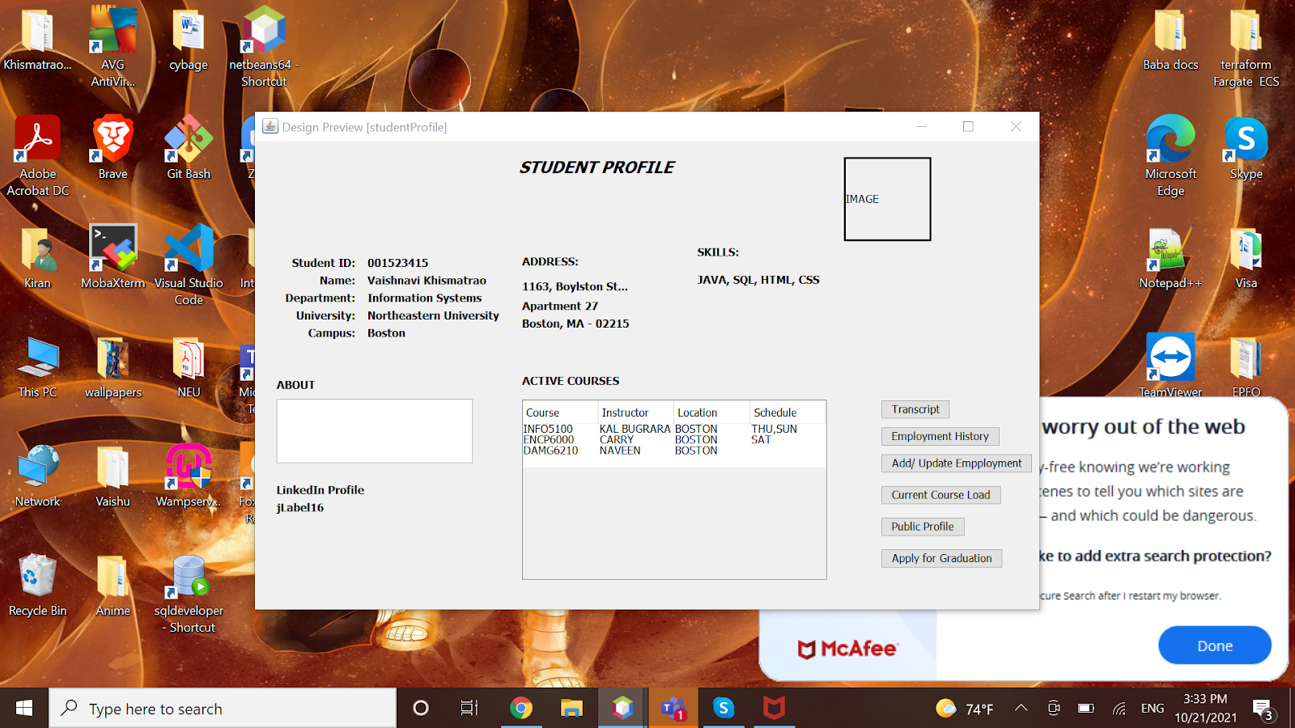

* Course Review Dashboard

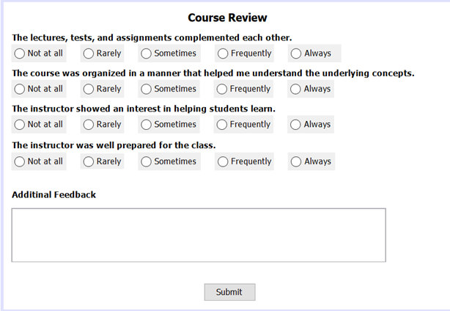

* Employment Dashboard

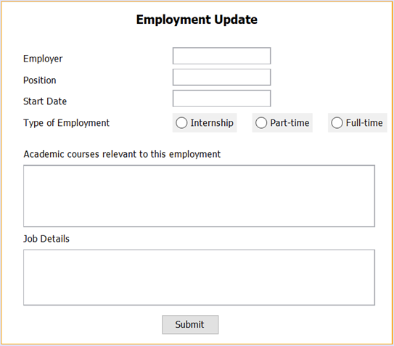

**Sequence Diagram:**

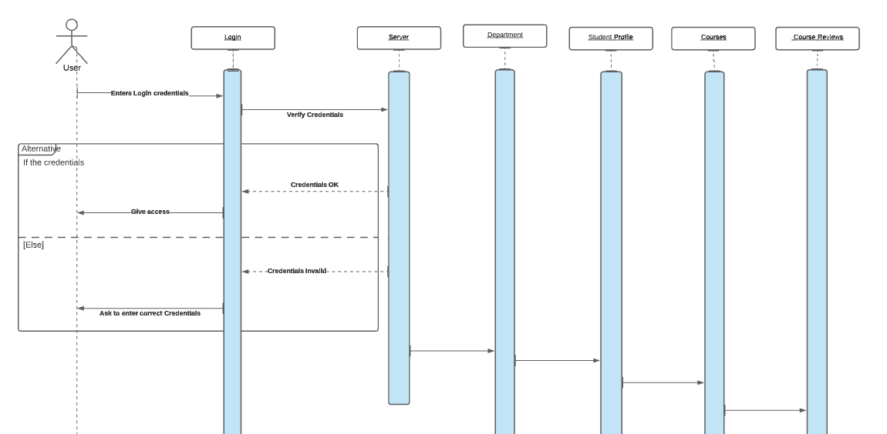

                Sequence diagram for an user (student) to enter course reviews

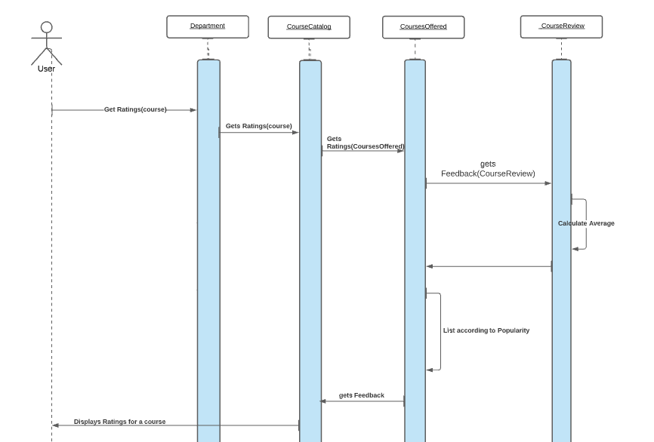

Sequence diagram for an user to get ratings for a course

**Object Model:**

